Edge Detection Shader

This is the tutorial online that I found that taught me how to a good edge shader with lots of features: <https://roystan.net/articles/outline-shader.html>

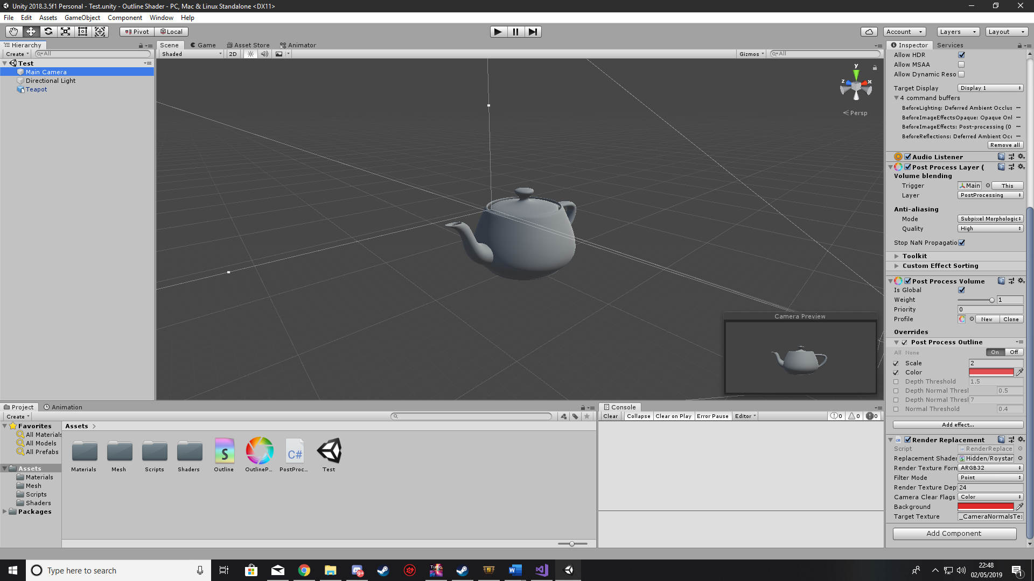How to use

There are a number effects are available that change the line: You can change the thickness which is scale, you can change the colour as well and you can also change the threshold which changes how sensitive the edge detection is and how much it’ll shade.